Metrics used in Testing

🔹 Definition
# Source: Chatgpt (GPT-5-Standard) at [8/18/2025]
Testing Metrics are quantitative measures used to assess the effectiveness, quality, and progress of the testing process.
They help:
- Track test progress
- Measure product quality
- Identify risks and bottlenecks
- Support decision-making (e.g., release readiness)

🛠️ Types of Testing Metrics

1. Test Process Metrics
# Source: Chatgpt (GPT-5-Standard) at [8/18/2025]
(Measure progress and effectiveness of the test process)
- Test Case Execution Status → % of test cases passed, failed, blocked.
- Test Progress → number of tests executed vs planned.
- Test Coverage → % of requirements or code covered by tests.
- Defect Detection Percentage (DDP) → defects found during testing vs total defects (testing + production).
- Test Effort Variance → planned effort vs actual effort spent on testing.

2. Product Quality Metrics
# Source: Chatgpt (GPT-5-Standard) at [8/18/2025]
(Measure product quality and readiness for release)
- Defect Density → number of defects per module / per 1,000 lines of code (KLOC).
- Defect Severity Index (DSI) → average severity of defects.
- Mean Time to Detect (MTTD) → average time to find a defect.
- Mean Time to Repair (MTTR) → average time to fix defects.
- Escaped Defects → number of defects found in production.

3. Defect Metrics
# Source: Chatgpt (GPT-5-Standard) at [8/18/2025]
(Focus on defect tracking and analysis)
- Defect Distribution → defects by module/component.
- Defect Age → how long defects remain open.
- Defect Removal Efficiency (DRE) →

DRE=Defects removed during testingTotal defects (testing + production)×100\text{DRE} = \frac{\text{Defects removed during testing}}{\text{Total defects (testing + production)}} \times 100
- Reopen Rate → % of defects that reappear after being fixed.

4. Effort & Cost Metrics
# Source: Chatgpt (GPT-5-Standard) at [8/18/2025]
(Related to resources and time spent)
- Test Effort per Requirement → hours spent testing per requirement.
- Cost of Quality (CoQ) → cost of testing, prevention, and fixing defects.
- Return on Investment (ROI) for Test Automation → cost savings from automation vs manual effort.

📊 Example Table – Testing Metrics in a Web App Project
# Source: Chatgpt (GPT-5-Standard) at [8/18/2025]
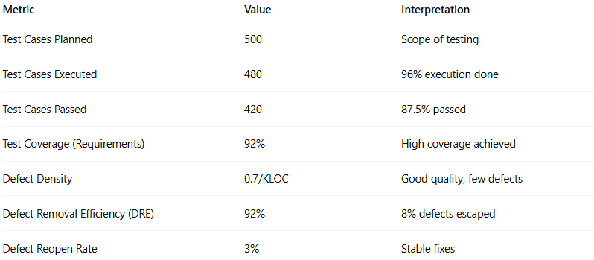
Metric | Value | Interpretation
Test Cases Planned | 500 | Scope of testing
Test Cases Executed | 480 | 96% execution done
Test Cases Passed | 420 | 87.5% passed
Test Coverage (Requirements) | 92% | High coverage achieved
Defect Density | 0.7/KLOC | Good quality, few defects
Defect Removal Efficiency (DRE) | 92% | 8% defects escaped
Defect Reopen Rate | 3% | Stable fixes

✅ Why Testing Metrics Matter
# Source: Chatgpt (GPT-5-Standard) at [8/18/2025]
- Give visibility into test progress & product quality.
- Help project managers decide release readiness.
- Highlight risk areas (modules with high defect density).
- Provide continuous improvement insights.

👉 In short:
Metrics in Testing = numbers and measures that show how effective, efficient, and complete the testing process is, and how good the product quality is.

